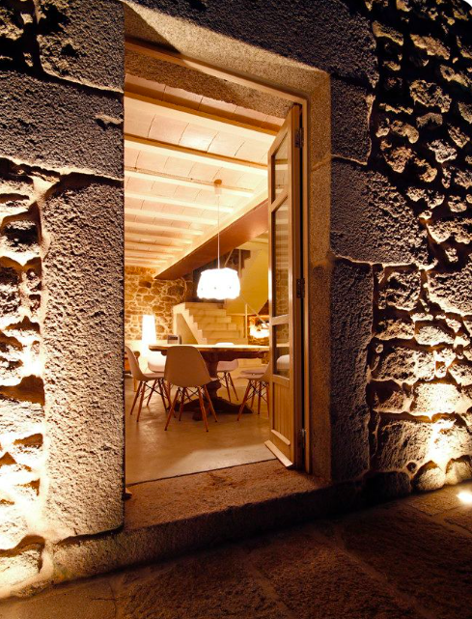
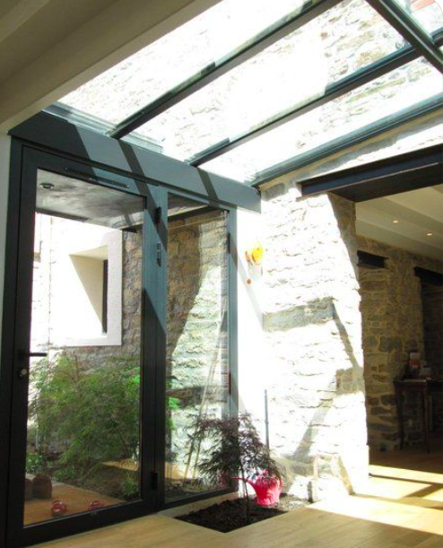

Illustration of what the glass link could look like Illustration of opening from Farm House into
From the inside the glass link towards Mill House

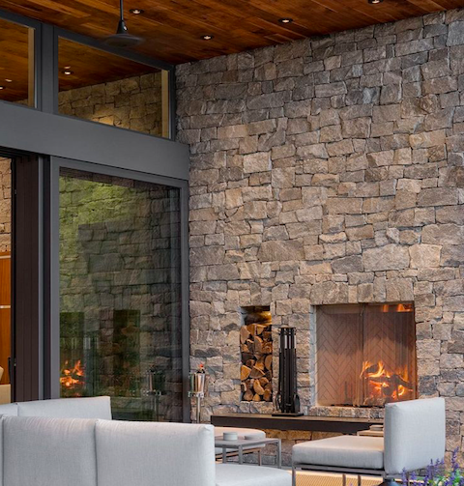
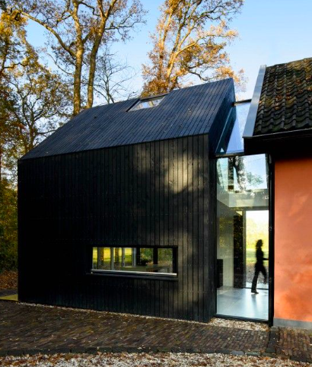

Depicting the adjoining glass link between the Illustration of the internal aesthetic of glass link
Farm House and the Mill House
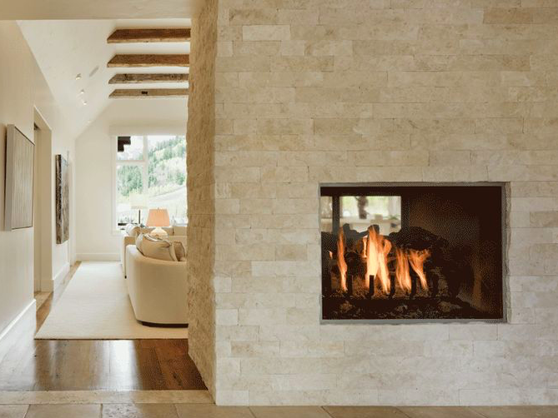

Illustrating the new opening and double inglenook into the glass link

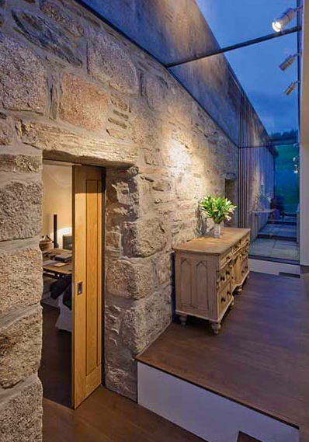
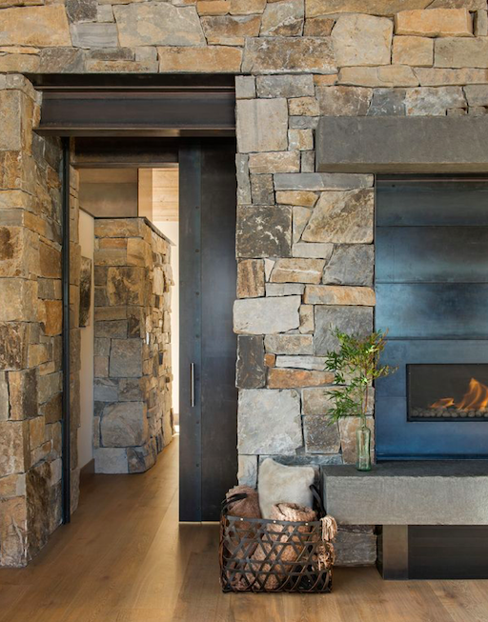

Illustrating the new opening and internally Illustrating the new opening and double
Inside the glass link inglenook into the glass link

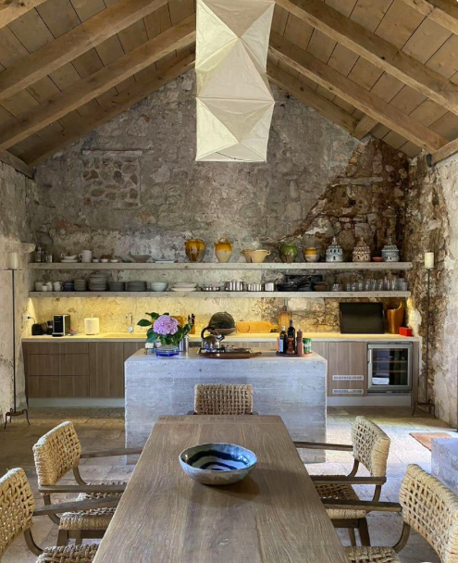
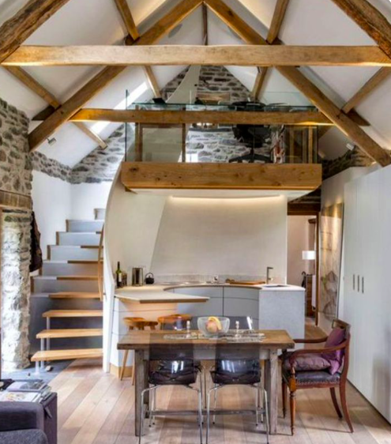

Illustration of internal aesthetic of the Mill House We would like to maintain as much original features as possible in the Mill House

