Proposed repair to Dwelling
At 2 Daniell Street, Truro, Cornwall Council

Design Statement

Introduction

The subject site, No. 2 Daniell Street, Truro, is located off the Falmouth Road, to the south of Truro City Centre. Part of a Grade II listed terrace of 24 similar houses the subject property was constructed Circa 1830. The listing information describes Daniell Street as ‘one of the best and most complete examples of early C19 planned terraces of small houses in this area.’

Justification for the works

The proposed works are being undertaken due to the current render being in a poor state of repair, with areas of cracking causing a potential hazards and increased damp in the property creating a health and safety risk. The current render has allowed water infiltration on the side of the property causing increased damp in the property.

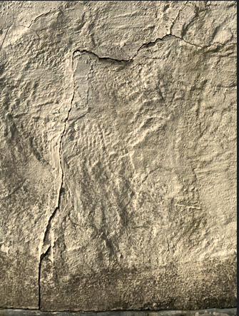
Render has deteriorated beyond repair and is at risk of falling off

Impact Assessment

The East side of the property is overlooked by number 2 and 4 Falmouth Road and is not viewable by the public from the street. The proposals will have no impact on the appearance of the property. To ensure the materials represent a more traditional mix that will allow the building to function in the way that it was intended (and there by respecting the character) a lime/ sand mix (no cement) render will be used. White lime wash will be used to match in with the other rear walls of the property.

Materials

Lime/ Sand mix render
White lime wash

Supervisor

Richard Tregunna – SMSTS qualified.

Access Statement

Scaffolding to be erected with plywood protection for the conservatory put in place, access via number 4 Falmouth road’s property. Nothing is required to the front of the property and so members of the public will not be affected. We expect the removal of the old render and replacement with new lime/ sand render to take approximately 2 weeks

Conclusion

The proposed works to the property are to replace the render to reduce the risk of injury or damage to people and other properties. Replacement of the render to the East wall will have minimal impact on the original structure and character of the Grade II listed building. We trust that this application will be fairly and favourably regarded within the Cornwall Council.

Listing Information for 2-25 Daniell Street Truro

TRURO
SW8244SW DANIELL STREET 880-1/10/35 (South side) Nos.2-25 (Consecutive)
GV II
Terrace of 24 similar houses. c1830. Roughly-coursed, dressed Killas with brick arches; Nos 16 & 17 have been rendered; dry Delabole slate roof to No.2, otherwise asbestos slate roofs; brick end stacks (some chimneys removed); cast-iron ogee gutters to Nos 7, 8, 16, 17, 22 & 25. Double-depth plan: each house has a reception room at the front and a kitchen behind, most with rear service wings; side entrance halls; through-passages (opes) between Nos 9, 10, 16, & 17. Two storeys; each house of 2-window range. Most are built in pairs with a pair of round-headed doorways in the centre, others have doorways to one side. All have round-headed doorways with blind fanlights; No.7 has original panelled door. Nos 2, 3, 6, & 21 (1st floor) have keyed segmental arches over original 16-pane hornless sashes otherwise altered or later sashes except for Nos 5, 8, 11, 23 & 24 which have C20 windows. Daniell Street has one of the best and most complete examples of early C19 planned terraces of small houses in this area.
Listing NGR: SW8222844419

