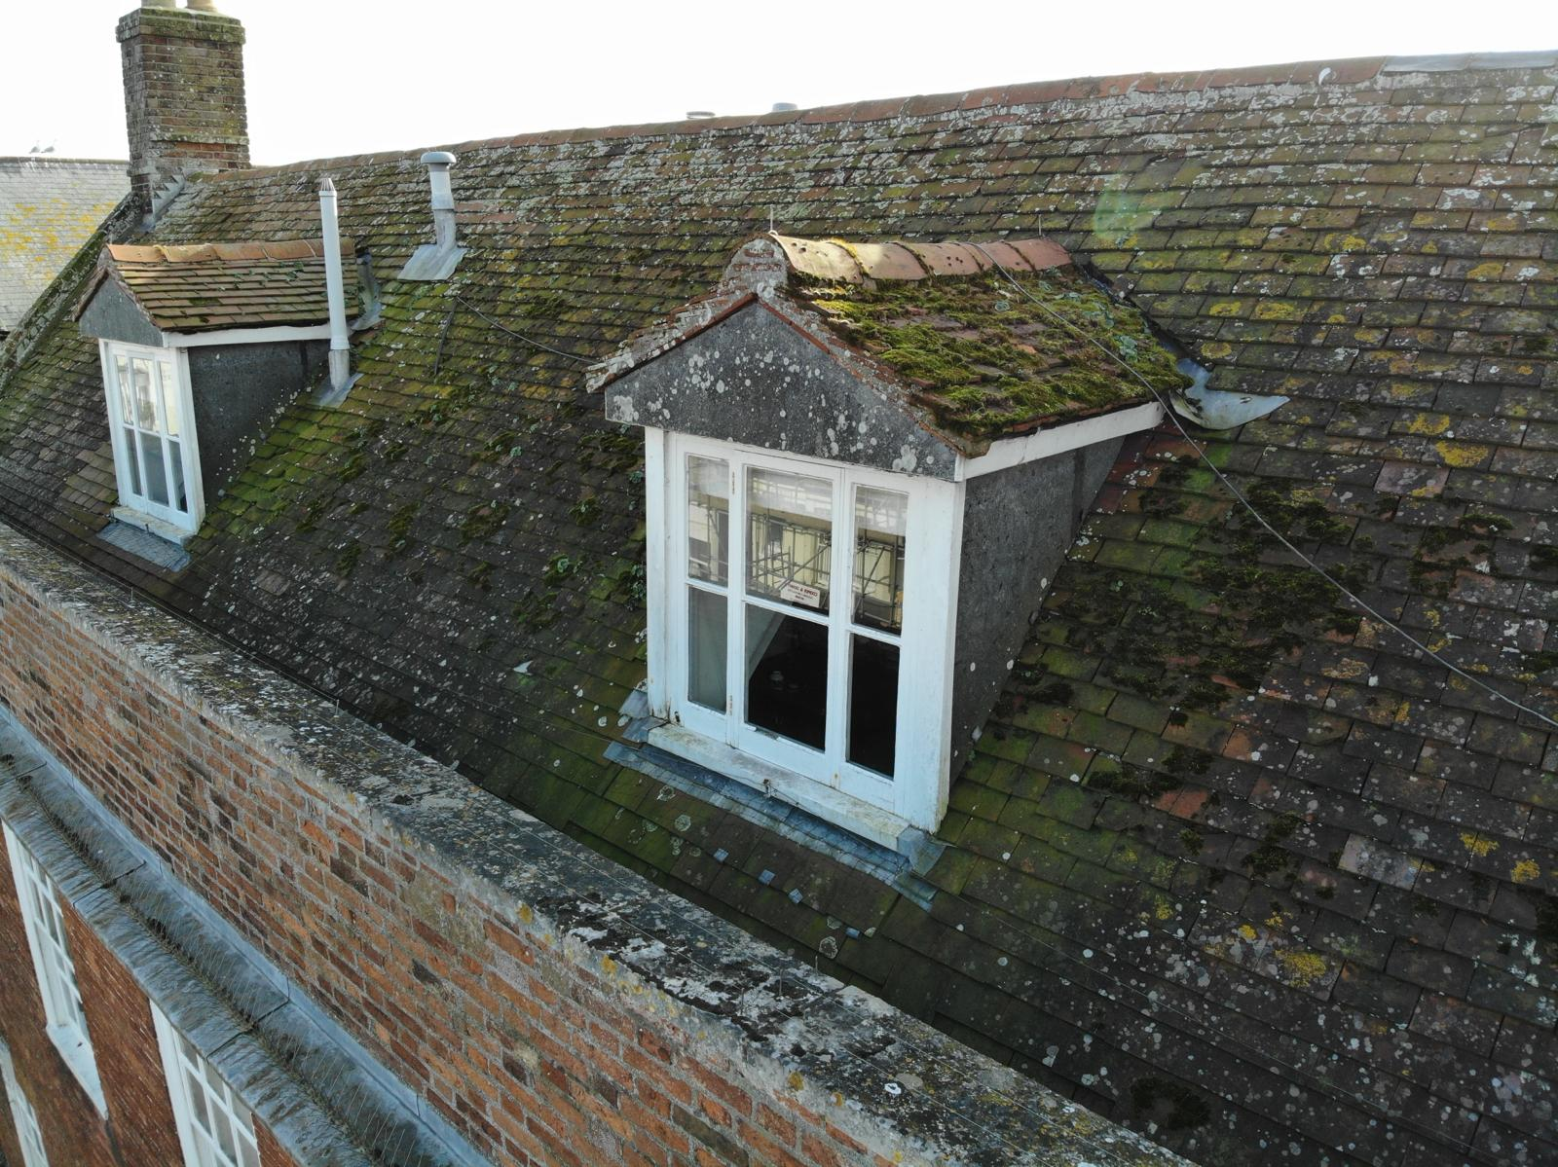
Dorner Pitched ~Roofs
The dormer roofs are low pitched and not suitable for Plain Clay tiles – the proposal is to repalce these with Del Carmen Spanish slate 10”x20” – With 50mm core roll ridge clad in Code 6 Sand Cast Lead

Vent Pipes to be removed and replaced with discrete Palin tile Vents

