Electric Vehicle Charging Points
The specification will be similar to the below:
https://www.hivehome.com/shop/electric-vehicles/alfen-eve-single-s-line?cid=ppc.cid_tool=goo.cid_ctype=bran.cid_cname=UK_Hive_Performance+Max&gad_source=1&gclid=CjwKCAiA7t6sBhAiEiwAsaieYi3SWDK9xQaH2J9m48DK5GjVKcTTOE2QjAKTeoxG7mR7YWtDZJCswRoC8akQAvD_BwE&gclsrc=aw.ds
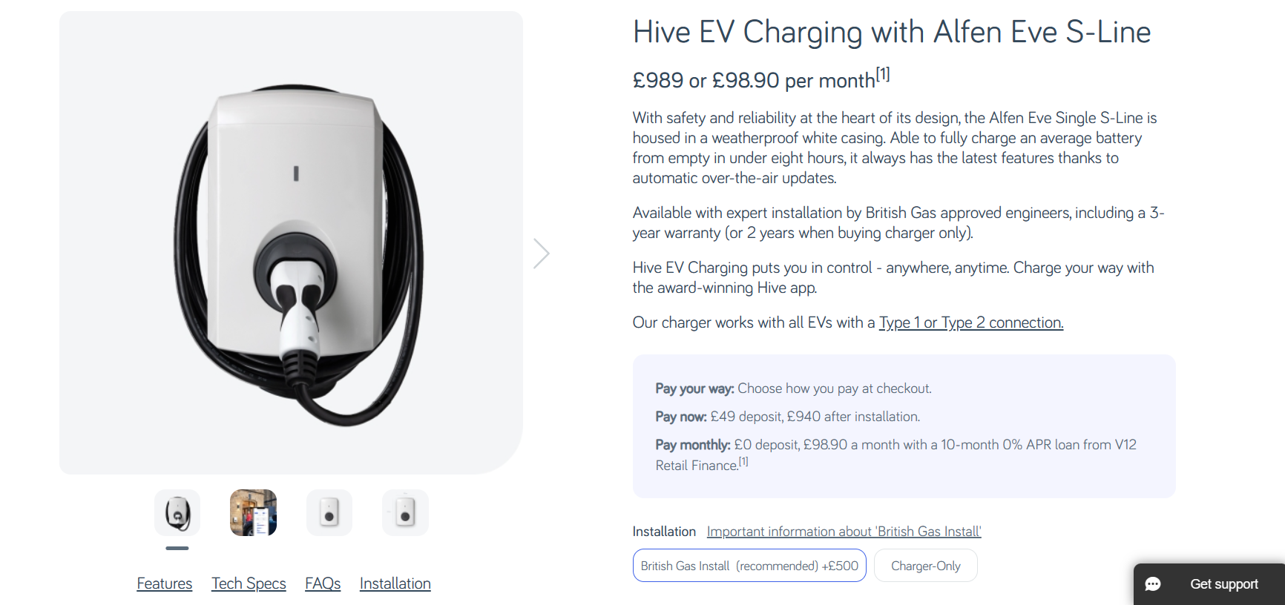
https://vorsprungofficial.com/products/ev-wall-charger-type-2-32a-7-4kw-5m?variant=43810927116515&currency=GBP&utm_medium=product_sync&utm_source=google&utm_content=sag_organic&utm_campaign=sag_organic&tm=tt&ap=gads&aaid=adaD8b2aapcgZ&gad_source=1&gclid=CjwKCAiA7t6sBhAiEiwAsaieYmg0C7n-BZw627wjOZh0l1ygnkzFgm8pBhPZOam6xyyWJ8kMoI49ZBoCKxQQAvD_BwE
