**Existing workshop/Garage photos**

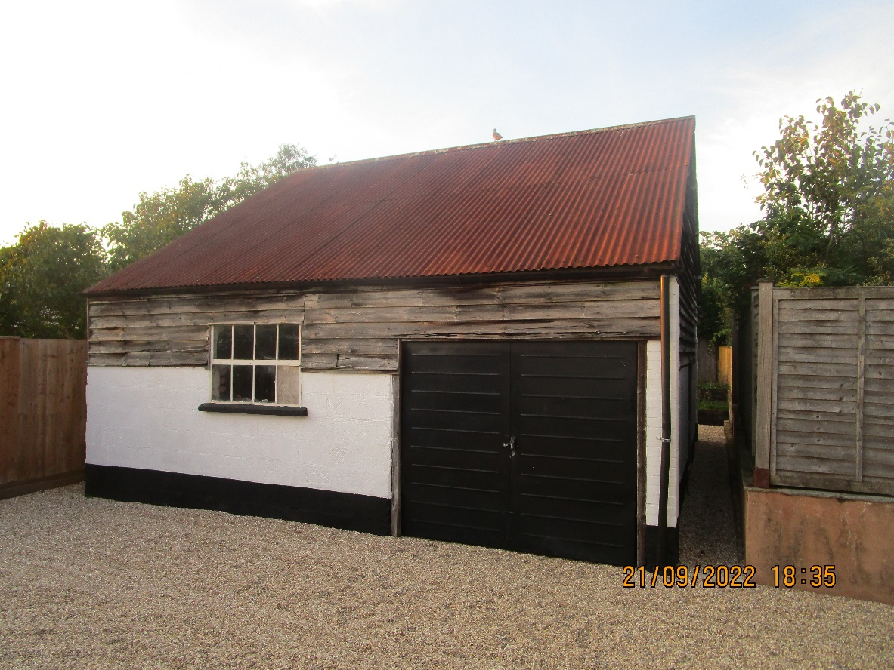

Southern elevation

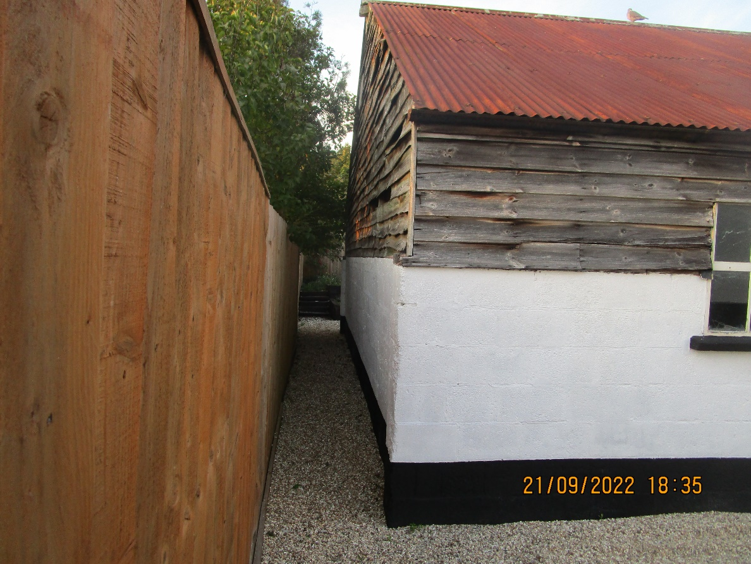

Southern and western elevation

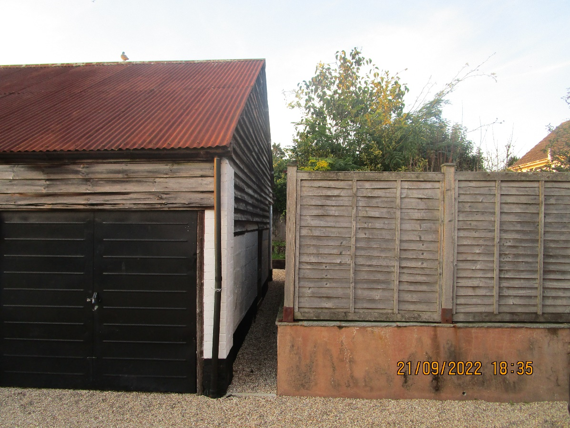

Southern and eastern elevation

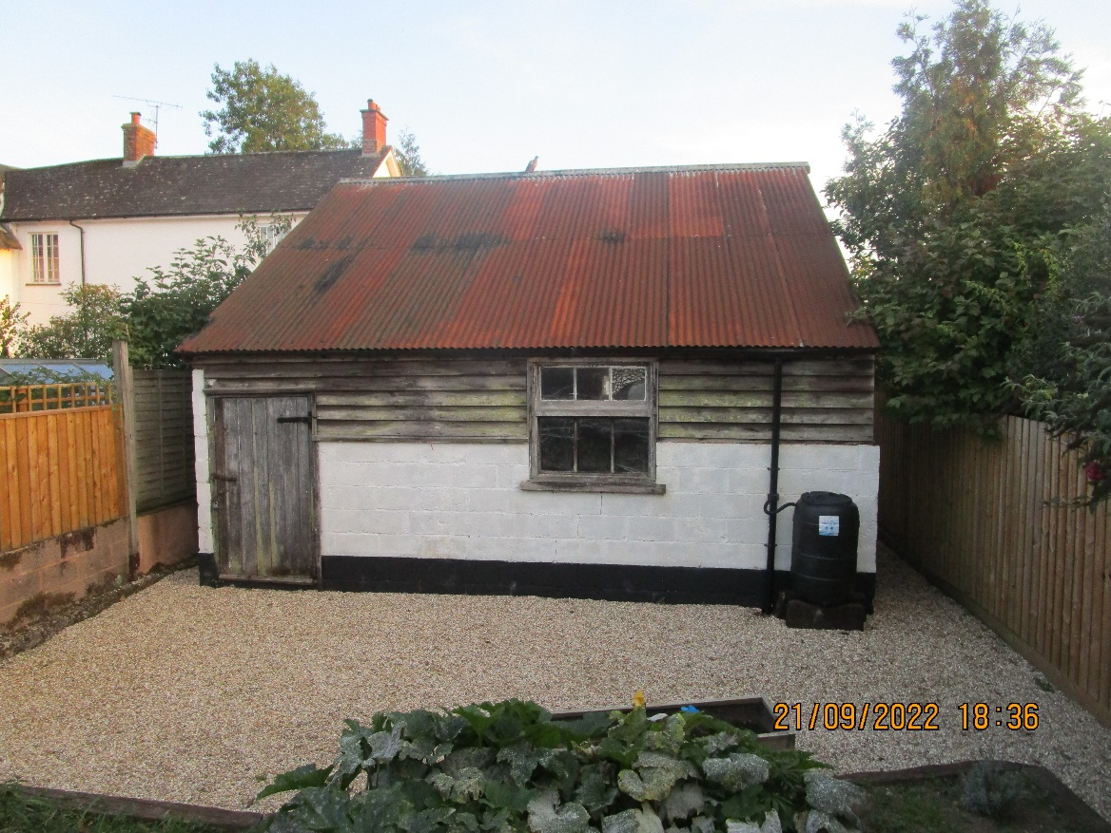

Northern elevation

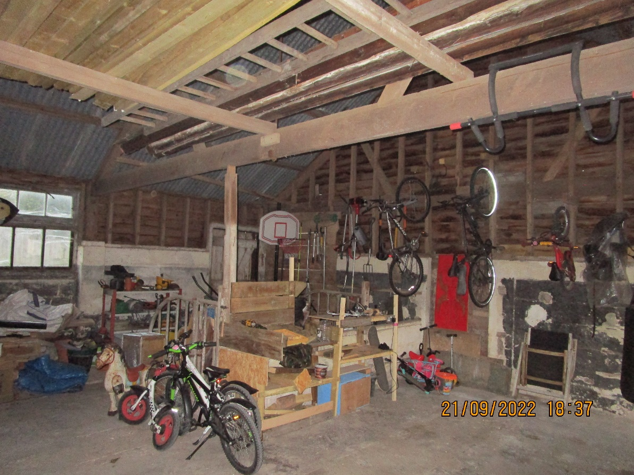

Internal view looking at the northern and western elevation

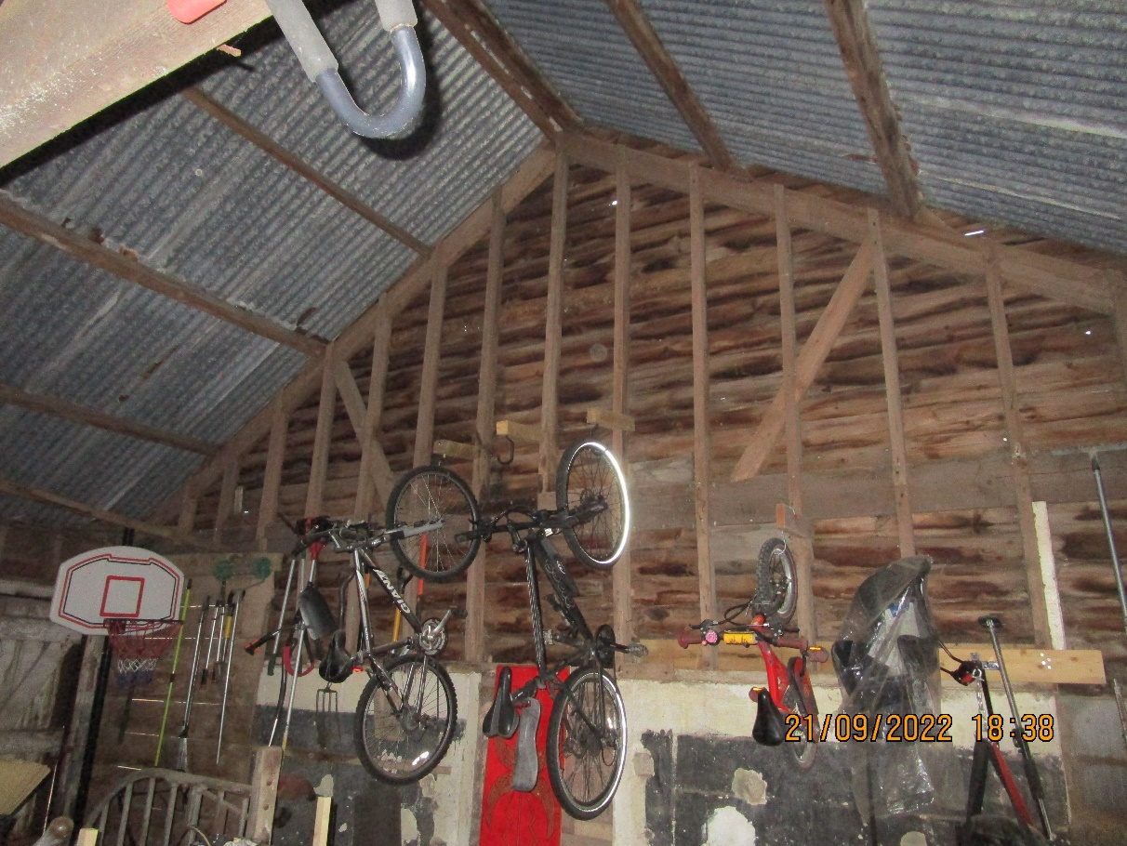

Internal view looking at the western elevation

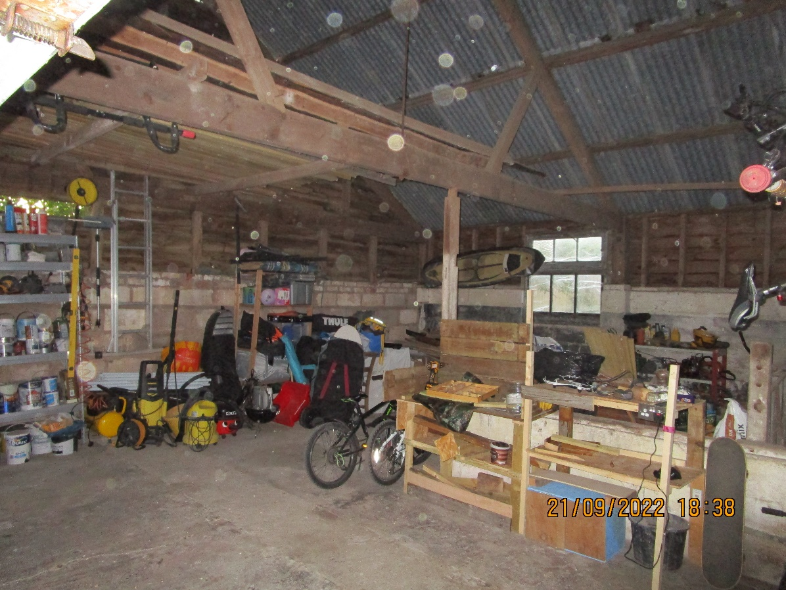

Internal view looking at the northern and western elevations

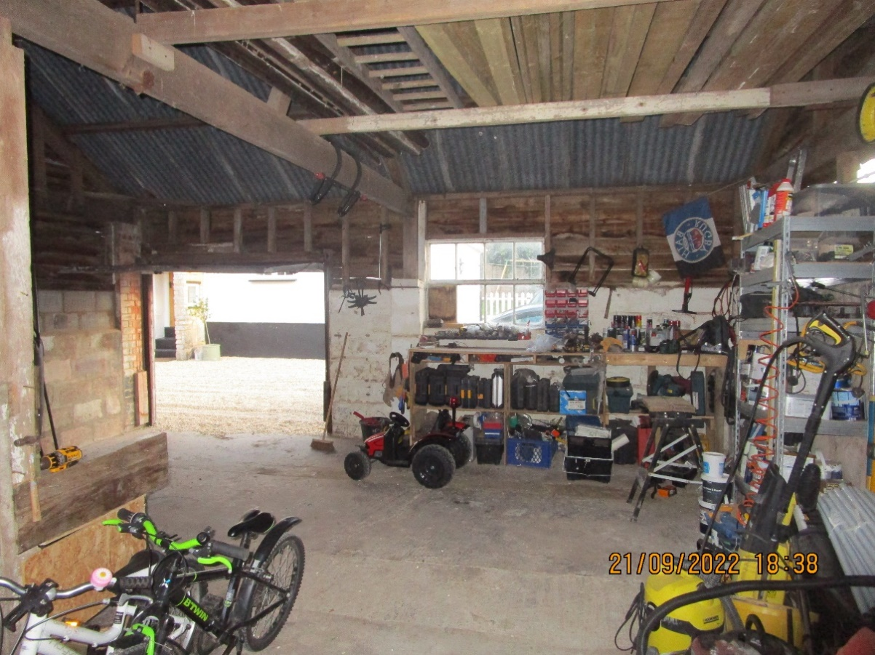

Internal view looking at the southern elevation

Existing front door of main building

View of main building containing kitchen.