Flood Consequences Assessment
Planning application for a small pig shelter and storage.

At Glyndwr House, Occupation Road
Blackwood, NP120EQ

On behalf of:
Kathryn Morgan

Prepared by:
Equestrian Blueprint
enquiries@equestrianblueprint.co.uk
https://equestrianblueprint.co.uk/
April 2024

Contents
Introduction 3
Site Area 3
Justification of Flood Zone 4
Use 4
Design Features 4
Summary 5
Conclusion 5

Introduction
A Flood Consequences Assessment (FCA) is an evaluation process used in planning and development to identify and assess the risks of flooding to, and from, a proposed development. It is an essential component of the planning application process for new developments, especially in areas prone to flooding.

Site Area
The application relates to land adjacent to the above address, the site area is located south of the garden. The site is used for the keeping of pigs as a hobby, apart from the garden area the land is wholly used for this purpose.

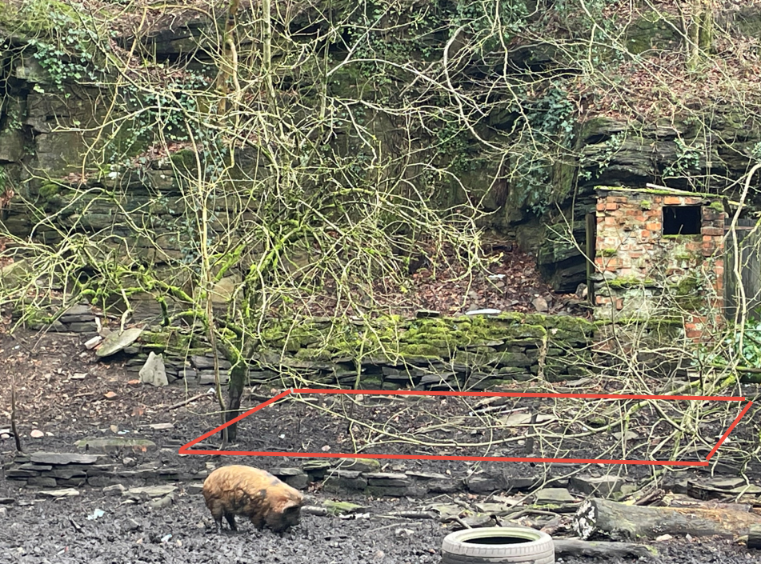

Justification of Flood Zone
Glyndwr House falls just within Flood Zone C1 an area of high flood risk the majority of the flood plain however is along the west bank of the river as the east bank is much higher, mainly by virtue of the access road and other, more elevated land. However the site area appears to be just inside Flood Zone C2.

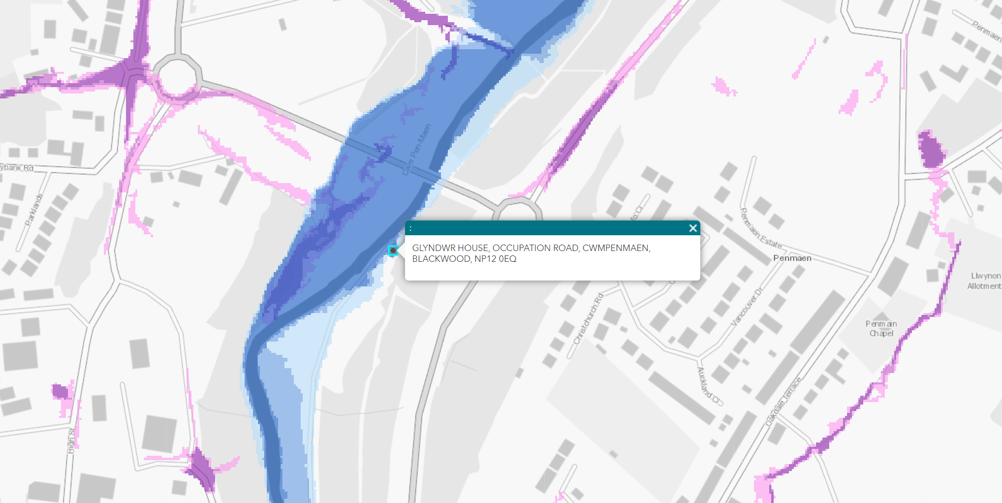

Use
The building will be used to house pigs and store other paraphernalia, it is not a building into which humans would normally go. Pigs would not be enclosed when flooding might be possible.

Design Features
The building is a very modest footprint of less than 52 square meters, land use and surface run off will be very modest.
The walls of the building will be constructed of pressure treated timber, and the floor will be made of concrete. Both of these are especially resilient and impervious to water. The walls will be raised off the concrete using a hollow metal channel, there will be no door thresholds. These measures will help any flood water to evacuate more readily and the timber sole plates to dry out. All of these measures aid quick recovery, post flood. The area chosen is the highest suitable ground.
A large amount of scrap metal and refuse was removed from the site in order to create a safer surface for the pigs. Any engineering required to install the concrete base would not decrease the flood plain capacity to any significant degree. This will result in a net gain in flood plain capacity.

Summary
The site area is on the edge of the flood zone and so the risk is limited. The building is designed and located to cope with flooding well and recover quickly. We suggest that this proposal does not increase flooding elsewhere or increase depth, velocity, hazard or extent of flood water.

Conclusion
The small pig shelter design meets with the requirements of final test IV of an FCA and contributes to a flood-resilient environment.

